**INDEX**

|  |
| --- |
| CHAPTER 1- INTRODUCTION |
|  |
| 1.1 Introduction about Project |
| 1.2 Objective |
| 1.3 Purpose |
| 1.4 Project Scope & Limitation |
| 1.5 Advantages of proposed system |
|  |
| CHAPTER 2- SURVEY OF TECHNOLOGIES |
|  |
| 2.1 Home Automation System |
| 2.2 Home Automation Standards |
| 2.3 Home Automation Implementation Platform |
| 2.4 Arduino IDE |
| 2.5 NodeMCU ESP8266 |
|  |
| CHAPTER 3- REQUIREMENT AND ANALYSIS |
|  |
| 3.1 Preliminary Investigation |
| 3.2 Limitations of System |
| 3.3 Feasibility Study |
| 3.4 Fact Finding Technique |
| 3.5 Use-Case Diagram |
| 3.6 Entity relationship diagram |
| 3.7 Activity Diagram |
| 3.8 Class Diagram |
| 3.9 Sequence Diagram |
| 3.10 Data Flow Diagram |
| 3.11 Planning Scheduling |
| 3.12 Hardware and Software Requirements |
|  |
| Chapter 4­- System Design |
|  |
| 4.1 Process Model |
| 4.2 Deployment Diagram |

**CHAPTER-1**

**INTRODUCTION**

**1.1 Introduction about Project**

This project is a miniature model of Home Automation System which can control home appliances with a remote which can be your own cell phone or your personal computer from anywhere. The basic ideology of this project is

that our home automation system and remote(phone/PC) must be connected to a dedicated to Wi-Fi Router. The basic idea of this home automation system is to provide the user with his/her estimated bill price monthly and of per day on the ThingSpeak cloud and hourly estimated billing on the serial monitor of the Arduino IDE.

With the use of this project the consumer can get the real-time estimated bill at the end of the day and also at the same time if the user consumes the same power the system will automatically calculate the estimated cost of the bill for the whole month, so that the consumer can decrease his bill by reducing the consumption. Because the things we can measure we can improve.

**1.2 Objective**

The objective of this project is to implement a low cost, reliable and scalable home automation system that can be used to remotely switch on or off any household appliance, using a microcontroller to achieve hardware simplicity, low cost short message service (SMS) for feedback and voice dial from any phone to toggle the switch state.

**1.3 Purpose**

In designing a home automation system, one or more suitable platforms are used in order to build a reliable and flexible system that can be easily operated and adapted for a new household appliance. Therefore, for the purpose of this project some specific deliberate choices were made on the type of platforms, hardware components and mode of operation of the home automation system.

**1.4 Project Scope & Limitation**

This project work is complete on its own in remotely and automatically switching on and off of any electrical appliance not limited to household appliances, and sends a feedback message indicating the new present state of the appliance. It does not implement control of multiple appliances or automatic detection of faults in the controlled appliance.

**1.5 Advantages of proposed system**

1. **Safety.**  The ability to control small appliances and lighting with your fingertips anywhere you are will add safety in your home.  You can make sure appliances are off when its needed to be off and on when its needed to be on.
2. **Security.**  The ability to lock the door through your phone is one of the greatest benefits of home automation.  This will give you peace of mind knowing that the door is close and not guessing.   The fact that you can be alerted each time someone enters your home also allows you to monitor who is entering your home at all times, especially when you are not there.
3. **Convenience.**  The ability to control everything with your fingertips is very convenient.  You never leave the house without your wallet, keys and your smart phone.  With our smart phone always with us, we can easily monitor our home and control everything with just touch of a finger.
4. **Saves Time.**  Since we are living in a very fast-paced environment, we don’t even have time to worry about our home.  With home automation, we can save time going back to our home and make sure everything is order, like if the kids close the door from school or turn on the lights when you get home.
5. **Save Money.**  This is the biggest advantage of home automation.  With the ability to control the light, whether dimming or turning on/off on specific time will saves homeowner a great ton of money.  You can save money through household temperature, with proper automation in window shades and automated thermostat.  In addition, you can save gas, by not driving back home if you forgot to turn off appliances or lock the door.

**CHAPTER-2**

**SURVEY OF TECHNOLOGIES**

* 1. **Home Automation System**

Home automation systems may designate electronic systems in homes and residential buildings that make possible the automation of household appliances. The new stream of home automation systems has developed into a vast one and the current market is flooded with a flurry of home automation systems and device manufacturers.

*The types of home automation systems based on their control systems are:*

**1. Individual Control Systems**

These types were the first to hit the market in the early years, here each device like the heater or the air conditioner will have an independent control dedicated to it.

**2. Distributed Control Systems**

The main feature of these type of systems is emergency shut-down. With this system you can preset or change the control parameters of several similar devices, for example, the thermostat of several air conditioners and their ON/OFF timings.

**3. Central Control Systems**

These are computerized systems programmed to handle all functions of multiple utilities like air conditioning system, home entertainments, doors, windows, refrigerators and cooking systems, all at the same time regardless of whether you are at home or away. You can connect to the control system through telephone or internet from anywhere in the world.

*The types of home automation systems based on the carrier mode are:*

**1. Powerline carrier Systems**

The least expensive type of home automation system operates over the home's existing wiring, or powerline carrier. These can range from X10based lamp timers, to more sophisticated systems that require installation by a trained professional.

**2. Wireless systems**

Also available are wireless home automation systems that utilize radiofrequency technology. They are often used to operate lights, sometimes in conjunction with a hardwired lighting control system.

**3. Hardwired systems**

Wired, or “hardwired” home control systems are the most reliable and expensive. These systems can operate over high-grade communications cable such as Category 5 or 5e, or their own proprietary “bus” cable. That is why it is best to plan for them when a house is being constructed. Hardwired systems can perform more tasks at a time and do them quickly and reliably, making them ideal for larger homes. They can also integrate more systems in the home, effectively tying together indoor and outdoor lighting, audio and video equipment, security system, even the heating and cooling system into one control package that will be easy and intuitive to operate.

**4. Internet Protocol control system**

Internet Protocol (IP) control automation system uses the internet, gives each device under its control an Internet Protocol address, and creates a local area network (LAN) in the home. Hence, the home can be interacted with over the internet with possibility of live video streaming and real-time control.

**2.2** **Home Automation Standards**

There are many established industry standards for home automation systems and are implemented over the various carrier modes ranging from powerline to wireless. The popular and major standards are INSTEON, European Home Systems (EHS), ZigBee, KNX, Z-Wave, X10, Lon Works, ONE-NET and Universal Powerline Bus (UPB).

1. **INSTEON standard**

INSTEON standard is a dual-band mesh topology employing ac-power lines and a radio frequency (RF) protocol to communicate with and automate home electronic devices and appliances, which normally work independently. It is a home automation networking technology invented by SmartLabs Inc. INSTEON was developed, based on the X10 model, for control and sensing applications in the home INSTEON is designed to enable simple devices to be networked together using the powerline and/or radio frequency.

1. **European Home Systems (EHS) protocol**

The European home systems (EHS) protocol was aimed at home appliances control and communication using power line communication (PLC). Developed by EHSA (European Home Systems Association) it was merged with two other protocols to form the KNX protocol, which complies with CENELEC norm EN 50090 standard and had a chance to be a basis for the first open standard for home and building control.

1. **ZigBee standard**

ZigBee is a specification for a suite of high-level communication protocols using small, low-power digital radios based on the IEEE 802.15.4-2003 standard for wireless personal area networks (WPANs), such as wireless headphones connecting with cell phones via short-range radio. The technology defined by the ZigBee specification is intended to be simpler and less expensive than other WPANs such as Bluetooth. ZigBee is targeted at radio frequency (RF) applications that require a low data rate, long battery life, and secure networking.

1. **KNX**

KNX is a standardized (EN 50090, ISO/IEC 14543), OSI-based network communications protocol for intelligent buildings. KNX is the successor to, and convergence of, three previous standards: the European Home Systems Protocol (EHS), BatiBUS, and the European Installation Bus (EIB). The KNX standard is administered by the Konnex Association.

1. **Z-Wave standard**

The Z-wave is a wireless communications proprietary standard designed for home automation, specifically to remote control applications in residential and light commercial environments. This technology, which is developed by Sigma designs' Zensys, uses a low power RF radio embedded or retrofitted into home electronics devices and systems, such as lighting, home access control, entertainment systems and household appliances. The technology has been standardized by the ZWave Alliance, an international consortium of manufacturers that oversees interoperability between Z-Wave products and enabled devices.

1. **X10 standard**

X10 is an international and open industry standard for communication among electronic devices used for home automation. It primarily uses power line wiring for signaling and control, where the signals involve brief radio frequency bursts representing digital information. X10 was developed in 1975 by Pico Electronics of Glenrothes, Scotland, in order to allow remote control of home devices and appliances. It was the first general purpose home automation network technology and remains the most widely available. Although a number of higher bandwidth alternatives exist including KNX, INSTEON, BACnet, and Lon Works, X10 remains popular in the home environment with millions of units in use worldwide, and inexpensive availability of new components.

1. **LonWorks**

LonWorks is a networking platform specifically created to address the needs of control applications. The platform is built on a protocol created by Echelon Corporation for networking devices over media such as twisted pair, power lines, fiber optics, and radio frequency. It is used for the automation of various functions within buildings such as lighting and HVAC (Heating, ventilating and air conditioning).

1. **ONE-NET standard**

ONE-NET is an open-source standard for wireless network designed for low-cost, low-power (battery operated) control networks for applications such as home automation, security and monitoring, device control, and sensor networks. ONE-NET is not tied to any proprietary hardware or software, and can be implemented with a variety of low-cost off-the-shelf radio transceivers and microcontrollers from a number of different manufacturers.

1. **Universal Powerline Bus**

The Universal Powerline Bus (UPB) is an industry emerging standard for communication among devices used for home automation. It uses powerline wiring for signaling and control. Household electrical wiring is used to send digital data between UPB devices. While in the X10 protocol, this digital data is encoded onto a 120 KHz carrier which is transmitted as bursts during the relatively quiet zero crossings of the 50 or 60 Hz AC alternating current waveform, the UPB protocol works differently.

**2.3** **Home Automation Implementation Platform**

1. **Powerline communication**

Powerline communication is a system for carrying data on a conductor also used for electrical power transmission. Though electrical power is transmitted over high voltage transmission lines, distributed over medium voltage and used inside buildings at lower voltages, powerline communication can be applied at each stage.

1. **RS232**

The RS232 stands for recommended standard number 232. The serial ports on most computers use a subset of the RS232 standard. The full RS232 standard specifies a 25-pin "D" connector of which 22 pins are used. Most of these pins are not needed for normal PC communications, and indeed, most new PCs are equipped with male D type connectors having only 9 pins, trading off compatibility with the standard against the use of less costly and more compact connectors.

1. **Ethernet**

Ethernet defines a number of wiring and signaling standards for the physical connection of two or more devices together. Ethernet was originally based on the idea of computers communicating over a shared coaxial cable acting as a broadcast transmission medium. The methods used show some similarities to radio systems, although there are fundamental differences, such as the fact that it is much easier to detect collisions in a cable broadcast system than a radio broadcast. The common cable providing the communication channel was likened to the ether and it was from this reference that the name "Ethernet" was derived. From this early and comparatively simple concept, Ethernet evolved into the complex networking technology that today underlies most local area networks. The coaxial cable was replaced with point-to-point links connected by Ethernet hubs and/or switches to reduce installation costs, increase reliability, and enable point-to-point management and troubleshooting. StarLAN was the first step in the evolution of Ethernet from a coaxial cable bus to a hub-managed, twisted-pair network. The advent of twisted-pair wiring dramatically lowered installation costs relative to competing technologies, including the older Ethernet technologies. Through the physical connection, Ethernet stations communicate by sending each other data packets, blocks of data that are individually sent and delivered.

1. **Bluetooth**

Bluetooth is an open wireless protocol for exchanging data over short distances from fixed and mobile devices, creating personal area networks (PANs). It was originally conceived as a wireless alternative to RS232 data cables. It can connect several devices, overcoming problems of synchronization. It is a standard and a communications protocol primarily designed for low power consumption, with a short range (power-class-dependent: 1 meter, 10 meters, 100 meters) based on low-cost transceiver microchips in each device. Bluetooth makes it possible for devices to communicate with each other when they are in range. Because the devices use a radio (broadcast) communications system, they do not have to be in line of sight of each other.

1. **Infrared**

Infrared (IR) radiation is electromagnetic radiation whose wavelength is longer than that of visible light (400 – 700 nm), but shorter than that of microwave radiation. It's wavelength spans between 750nm and 100 µm and is employed in short-range communication among devices that conform to the standards published by the Infrared Data Association (IrDA). Remote controls and IrDA devices use infrared light-emitting diodes (LEDs) to emit infrared radiation which is focused by a plastic lens into a narrow beam. The beam is modulated, i.e. switched on and off, to encode the data. The receiver uses a silicon photodiode to convert the infrared radiation to an electric current. It responds only to the rapidly pulsing signal created by the transmitter, and filters out slowly changing infrared radiation from ambient light. Infrared communications are useful for indoor use in areas of high population density. IR does not penetrate walls and so does not interfere with other devices in adjoining rooms. Infrared is the most common way for remote controls to command appliances.

1. **GSM**

GSM which stands for Global System for Mobile Communication, is the most popular standard for mobile phone communication in the world. It is used by over three billion people across more than 212 countries and territories. GSM basically provides voice call and short message service (SMS). It operates as a cellular network that mobile phones connect to by trying to search for cells in their immediate vicinity. The modulation used in GSM is Gaussian minimum shift keying (GMSK), a kind of continuous-phase frequency shift keying. In GMSK, the signal to be modulated onto the carrier is first smoothed with a Gaussian low-pass filter prior to being fed to a frequency modulator, which greatly reduces the interference to neighboring channels (adjacent channel interference). GSM networks operate in the 900 MHz or 1800MHz frequency bands in most countries of the world except in few countries like USA and Canada where 850 and 1900 MHz bands are used as the 900 and 1800 MHz bands were already allocated. The GSM technology uses a 200 KHz radio frequency channels that are time division multiplexed to enable up to eight users to access each carrier.

1. **Microcontroller**

A microcontroller is an inexpensive single-chip computer. Single-chip computer means that the entire computer system lies within the confines of the integrated circuit chip (Byte, 2002). The microcontroller on the encapsulated silver of silicon has features similar to those of our standard personal computer. Its ability to store and run unique programs makes it extremely versatile, and its ability to perform math’s and logic functions allows it to mimic sophisticated logic and electronic circuits. Microcontrollers are used in automatically controlled products and devices, such as automobile engine control systems, remote controls, office machines, appliances, power tools and toys. Hence, microcontrollers due not function in isolation, they accept input from one or more devices and provide output to other devices within a given system. In fact, they are responsible for the intelligence in most smart devices in the consumer market.

*The microcontroller has two general architecture types that define its mode of operation and design.*

1. **Von-Neumann architecture**

This architecture has a single, common memory space where both program instructions and data are stored. There is a single data bus which fetches both instructions and data. And each time the CPU fetches a program instruction it may have to perform one or more read/write operations to data memory space. It must wait until these subsequent operations are complete before it can fetch and decode the next program instruction. The advantage to this architecture lies in its simplicity and economy. On some Von Neumann machines the program can read from and write to CPU registers, including the program counter. This can be dangerous as you can point the processor to memory blocks outside program memory space and careless processor manipulation can cause errors which require a hard reset.

1. **Harvard architecture**

This architecture implements separate memory areas for program instructions and data. There are two or more internal data buses which allow simultaneous access to both instructions and data. The CPU fetches instructions on the program memory bus. If the fetched instruction requires an operation on data memory, the CPU can fetch the next program instruction while it uses the data bus for its data operation. These speeds up execution time at the cost of more hardware complexity. Most modern microcontrollers have the Harvard architecture.

* 1. **Arduino IDE**

The Arduino Integrated Development Environment - or Arduino Software (IDE) - contains a text editor for writing code, a message area, a text console, a toolbar with buttons for common functions and a series of menus. It connects to the Arduino and Genuino hardware to upload programs and communicate with them.

Programs written using Arduino Software (IDE) are called **sketches**. These sketches are written in the text editor and are saved with the file extension .ino. The editor has features for cutting/pasting and for searching/replacing text. The message area gives feedback while saving and exporting and also displays errors. The console displays text output by the Arduino Software (IDE), including complete error messages and other information. The bottom righthand corner of the window displays the configured board and serial port. The toolbar buttons allow you to verify and upload programs, create, open, and save sketches, and open the serial monitor.

|  |  |
| --- | --- |
|  | ***Verify***  Checks your code for errors compiling it. |
|  | ***Upload***  Compiles your code and uploads it to the configured board. See [uploading](https://www.arduino.cc/en/guide/environment#uploading) below for details. |
|  | ***New***  Creates a new sketch. |
|  | ***Open***  Presents a menu of all the sketches in your sketchbook. Clicking one will open it within the current window overwriting its content. |
|  | ***Save***  Saves your sketch. |
|  | ***Serial Monitor***  Opens the [serial monitor](https://www.arduino.cc/en/guide/environment#serialmonitor). |

* 1. **NodeMCU ESP8266**

NodeMCU is an open source [IoT](https://en.wikipedia.org/wiki/Internet_of_Things) platform. It includes [firmware](https://en.wikipedia.org/wiki/Firmware) which runs on the [ESP8266](https://en.wikipedia.org/wiki/ESP8266) [Wi-Fi](https://en.wikipedia.org/wiki/Wi-Fi) [SoC](https://en.wikipedia.org/wiki/System_on_a_chip) from Espressif Systems, and hardware which is based on the ESP-12 module. The term "NodeMCU" by default refers to the firmware rather than the development kits. The firmware uses the [Lua](https://en.wikipedia.org/wiki/Lua_(programming_language)) scripting language. It is based on the eLua project, and built on the Espressif Non-OS SDK for ESP8266.

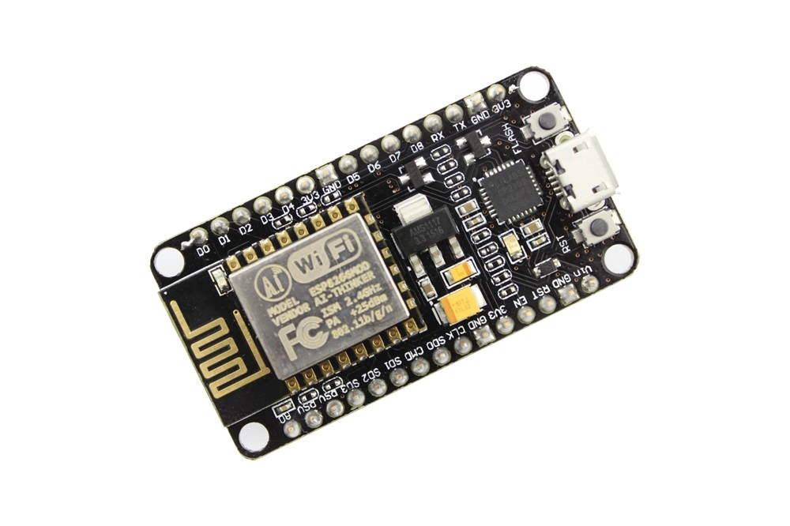

NodeMCU Development board is featured with Wi-Fi capability, analog pin, digital pins and serial communication protocols. To get start with using NodeMCU for IoT applications first we need to know about how to write/download NodeMCU firmware in NodeMCU Development Boards. And before that where this NodeMCU firmware will get as per our requirement. There is online NodeMCU custom builds available using which we can easily get our custom NodeMCU firmware as per our requirement.

**CHAPTER-3**

**REQUIREMENT AND ANALYSIS**

**3.1 Preliminary Investigation**

In designing a home automation system, one or more suitable platforms are used in order to build a reliable and flexible system that can be easily operated and adapted for a new household appliance. Therefore, for the purpose of this project some specific deliberate choices were made on the type of platforms, hardware components and mode of operation of the home automation system.

Before the actual design of the project work, specific deliberate choices in selection of appropriate implementation platforms and hardware components were made. Priority was given to low cost availability, reliability, flexibility and simplicity in all these selections.

**3.2 Limitations Of System**

**1. Cost**

The biggest problems, con or disadvantage of a smart home system is the cost. There are quite a number of companies that provide the smarty home system, but all of them are quite expensive. This is something that only a few can afford. You would be able to have a good savings and income to install this system.

**2. Dependency on Internet:**

The basic requirement for the smart home system is the internet. Without a good and strong internet connection, you will not be able to take control of this. If there is no internet connection for some reason, there is no other way through which you can access and control your system.

**3.Dependency on Professionals:**

In case there is a problem with the smart home system, you cannot simply call a handyman or someone similar to repair or manage the bug. You will have to depend on the professionals. Only the company professionals can help you to handle the problems. A professional would be able to take care of the disadvantages of home appliances.

**3.3 Feasibility Study**

This project can be implemented using affordable electronic and software technology making it economically, technically and operationally feasible.

**Economic Feasibility**

This project is based on android phone based and few electronic components like NodeMCU microprocessor, relay switches, Batteries etc. which are affordable, making it economically feasible to implement.

**Technical Feasibility**

This project is based on wireless technology and embedded system which are reasonably in phase with currently used technology. Therefore, it is very much favored by the technology.

**Operational Feasibility**

This software will have very easy to use, user friendly interface so it will be pretty much operable by anyone having little experience of using android phone. It could be helpful for physically disabled person too, controlling home appliances with the click of a button. So it is operationally feasible.

**3.4 Fact Finding Technique**

The Fact-Finding method adopted are as follows:

**Interview:**

An interview with Prof. Vaibhav Sakpal who is a faculty at “Vasai College of Science and Technology” was conducted. The Questions related to the entire procedure of the current system was asked. Some of the questions about the job and reports for the month were asked.

*Some of the related Questions are:*

**Why You Choose this Project?**

In an Interview with Mr. Vaibhav Sakpal. I came to know that people want convenience that extra gimmick features. My Smart Home Automation project can ease the people’s life by giving convenience.

**How will your System work?**

By using my project, the people can connect normal household appliances to the world of internet. By connecting to the internet, the people can control their appliances with the help of phone or voice control.

**What will the cost for convenience?**

There will be no cost, if it will the makes the people’s life convenient. But nothing is free in world, but it will be very reliable to install and make people's life convenient

**How will your system differ from other competitors?**

We can connect smart assistance like Google, Siri, Alexa and Bixby to control it with the help of Voice Control.

**What will be the requirements for the automation?**

There is nothing much required than my system and an active internet connection to make all the devices smart and convenient.

**3.5 Use Case Diagram**

A Use case is a description of set of sequence of actions. Graphically it is rendered as an ellipse with solid line including only its name. Use case diagram is a behavioural diagram that shows a set of use cases and actors and their relationship. It is an association between the use cases and actors. An actor represents a real-world object. Primary Actor – Sender, Secondary Actor Receiver.

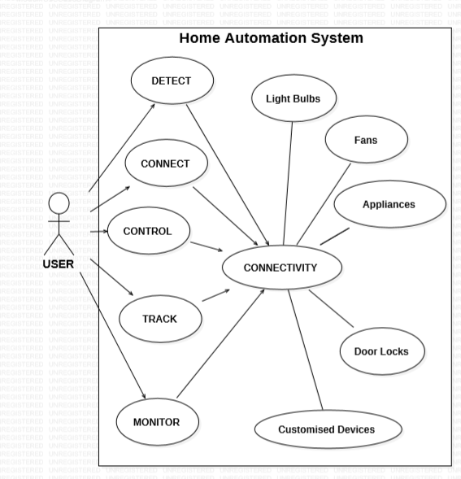

**3.6 Entity Relationship Diagram**

Entity Relationship Diagram, also known as ERD, ER Diagram or ER model, is a type of structural diagram for use in database design. An ERD contains different symbols and connectors that visualize two important information: The major entities within the system scope, and the inter-relationships among these entities.

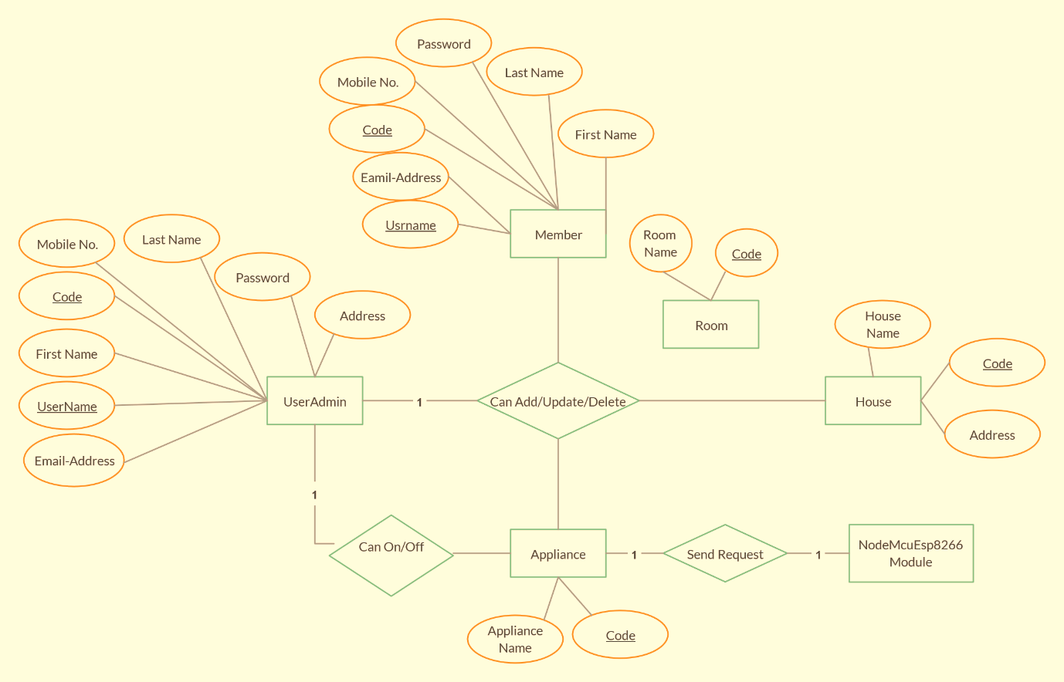

**3.7 Activity Diagram**

Activity diagram is basically a flowchart to represent the flow from one activity to another activity. The activity can be described as an operation of the system.

The control flow is drawn from one operation to another. This flow can be sequential, branched, or concurrent. Activity diagrams deal with all type of flow control by using different elements such as fork, join, etc.

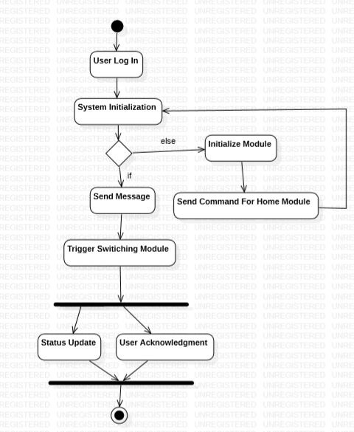

**3.8 Class Diagram**

Class is nothing but a structure that contains both variables and methods. The Class Diagram shows a set of classes, interfaces, and collaborations and their relating ships. There is most common diagram in modelling the object-oriented systems and are used to give the static view of a system. It shows the dependency between the classes that can be used in our system.

The interactions between the modules or classes of our projects are shown below. Each block contains Class Name, Variables and Methods.

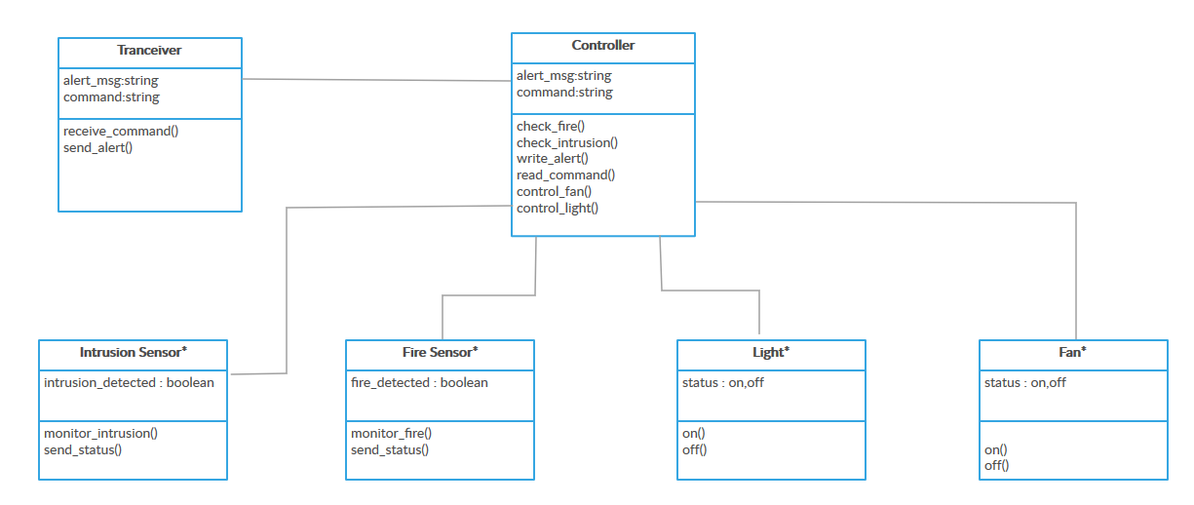

**3.9 Sequence Diagram**

Sequence diagram and collaboration diagram are called INTERACTION DIAGRAMS. An interaction diagram shows an interaction, consisting of set of objects and their relationship including the messages that may be dispatched among them

A sequence diagram is an introduction that empathizes the time ordering of messages. Graphically a sequence diagram is a table that shows objects arranged along the X-axis and messages ordered in increasing time along the Y-axis

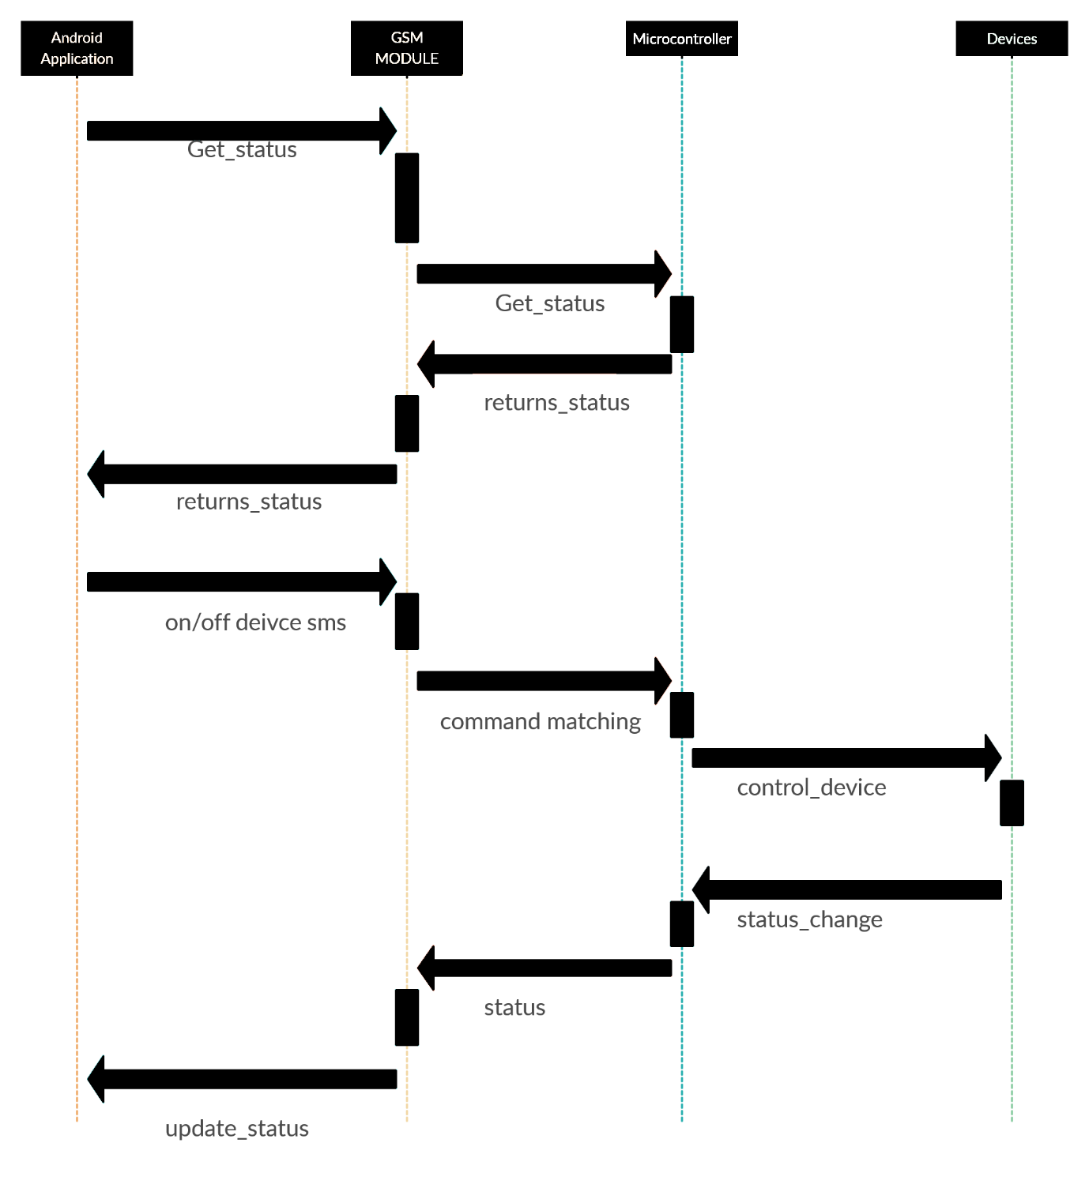

**3.10 Data Flow Diagram**

A data-flow diagram is a way of representing a flow of a data of a process or a system (usually an information system). The DFD also provides information about the outputs and inputs of each entity and the process itself. ... The data-flow diagram is part of the structured-analysis modelling tools.

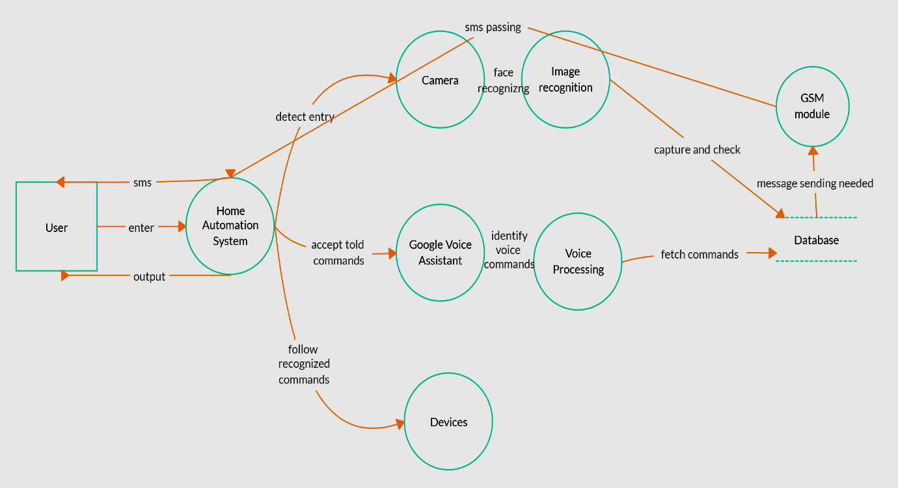

**3.11 Component Diagram**

A component diagram, also known as a UML component diagram, describes the organization and wiring of the physical components in a system. Component diagrams are often drawn to help model implementation details and double-check that every aspect of the system's required functions is covered by planned development. In the first version of UML, components included in these diagrams were physical: documents, database table, files, and executables, all physical elements with a location.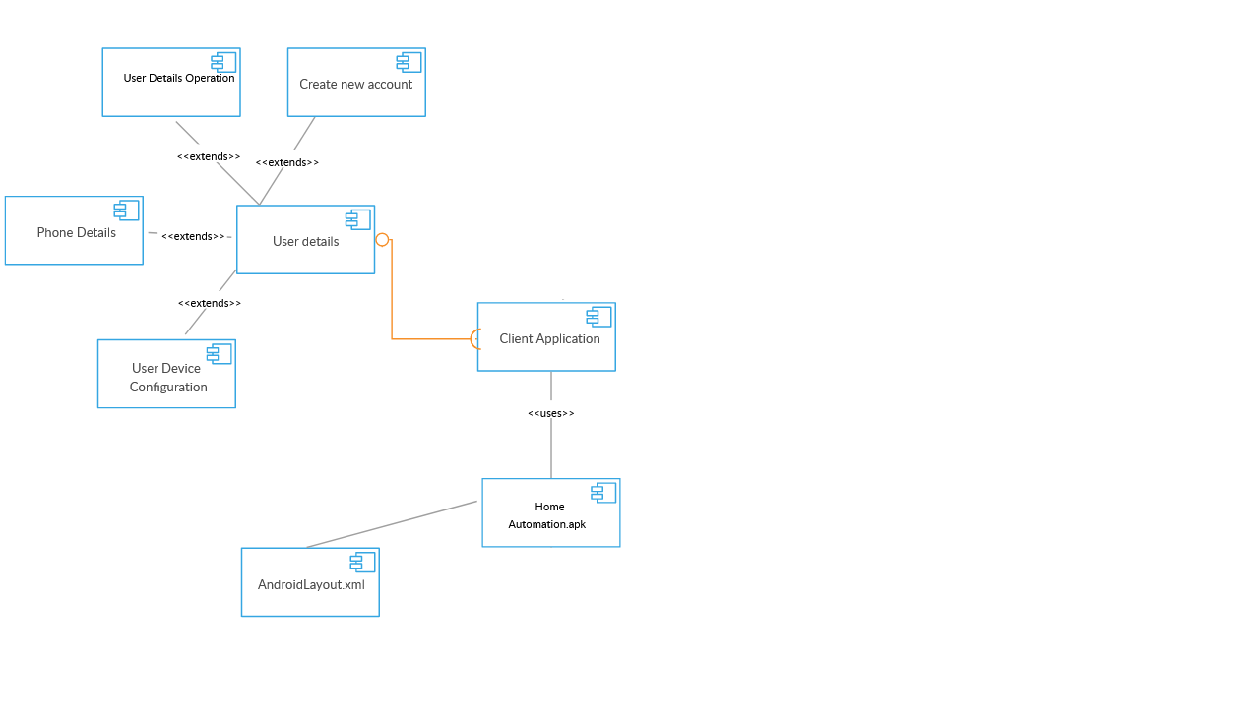

**3.12 Collaboration Diagram**

A collaboration diagram, also known as a communication diagram, is an illustration of the relationships and interactions among software [objects](https://searchmicroservices.techtarget.com/definition/object) in the Unified Modelling Language ([UML](https://searchsoftwarequality.techtarget.com/definition/Unified-Modeling-Language)). These diagrams can be used to portray the dynamic behaviour of a particular [use case](https://searchsoftwarequality.techtarget.com/definition/use-case/) and define the role of each object

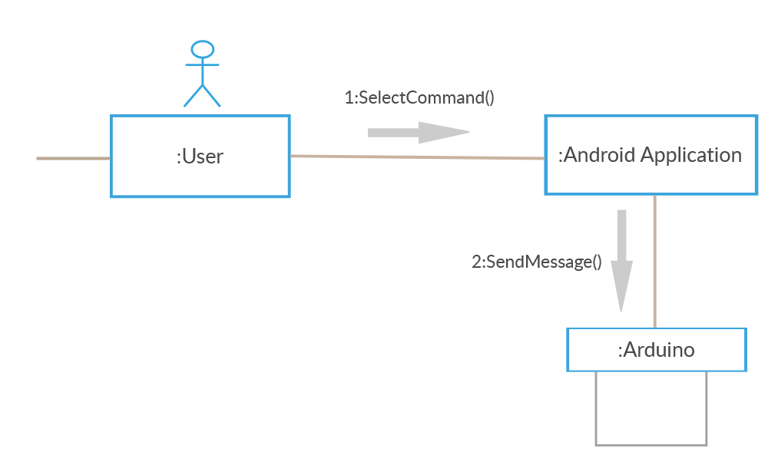

**3.13 Planning Scheduling**

**3.14 Hardware and Software Requirements**

1. **Hardware**

* NodeMCU (ESP8266-12E)
* 4-Channel Relay Module
* Jumper Wire
* Micro USB Cable

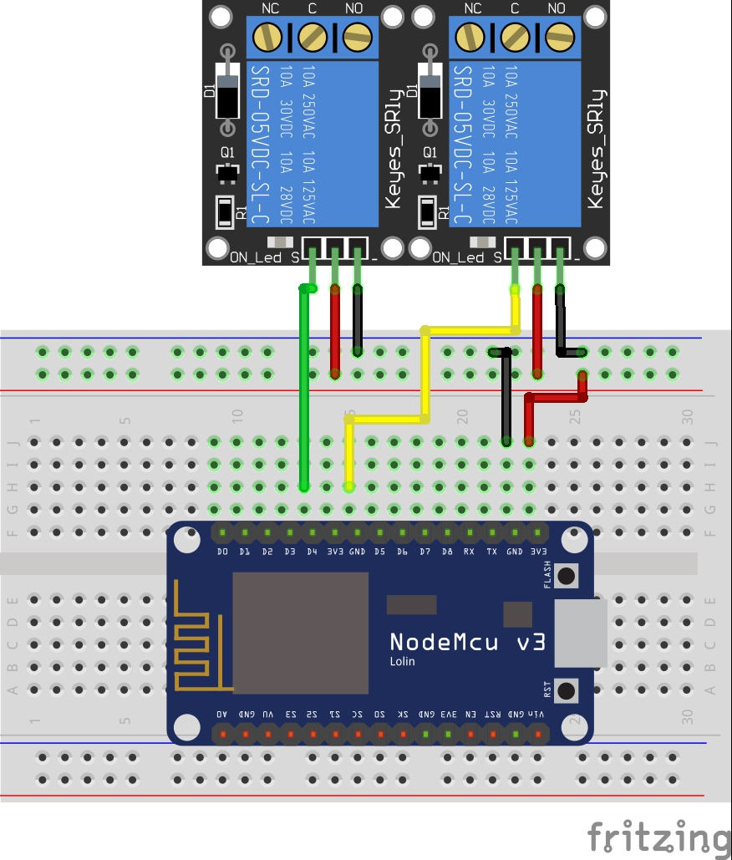

### SCHEMATICS

1. **Software**

* Arduino IDE
* ESP8266 package
* Blynk Libraries

**3.15 Coding**

#define BLYNK_PRINT Serial

#include <ESP8266WiFi.h>

#include <BlynkSimpleEsp8266.h>

char auth[] = "YourAuthToken";

char ssid[] = "YourNetworkName";

char pass[] = "YourPassword";

void setup()

{

// Debug console

Serial.begin(9600);

Blynk.begin(auth, ssid, pass);

}

void loop()

{

Blynk.run();

}

**CHAPTER-4**

**SYSTEM DESIGN**

**4.1 Process Model**

The simplest process model is the waterfall model, which states the Phases are organized in the linear order. The model was originally proposed by Royce, though variations of the model have evolved depending on the nature of activities and the flow of control between them. In this model, a project begins with feasibility analysis.

**Steps: -**

* Project Planning Phase
* Analysis Phase
* Design Phase (architecture, system, detailed)
* Coding Phase
* Testing Phase
* Software manuals (e.g. – user, installation, etc.)

**Project Planning Phase**

**Design Phase**

**Analysis Phase**

**Coding Phase**

**Testing Phase**

**Implementation Phase**

**4.2 Deployment Diagram**

A deployment diagram is a UML diagram type that shows the execution architecture of a system, including nodes such as hardware or software execution environments, and the middleware connecting them. Deployment diagrams are typically used to visualize the physical hardware and software of a system

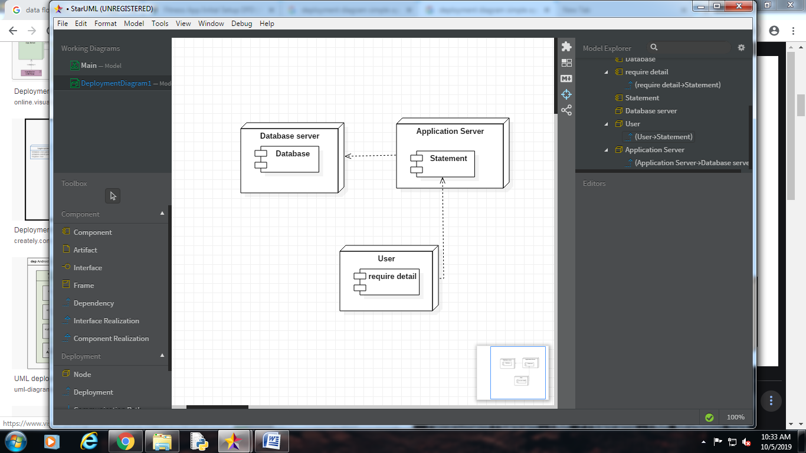

**BIBLIOGRAPHY**

[**http://www.physics-and-radio-electronics.com/electronic-devices-and-circuits/rectifier/bridger**](http://www.physics-and-radio-electronics.com/electronic-devices-and-circuits/rectifier/bridger)[**ectifier.html**](http://www.physics-and-radio-electronics.com/electronic-devices-and-circuits/rectifier/bridgerectifier.html)

[**https://eeeproject.com/7812-voltage-regulator-short-description-2/**](https://eeeproject.com/7812-voltage-regulator-short-description-2/)[**https://www.engineersgarage.com/electronic-components/7805-voltage-regulator-ic**](https://www.engineersgarage.com/electronic-components/7805-voltage-regulator-ic)[**https://www.adafruit.com/product/2165**](https://www.adafruit.com/product/2165)

[**https://jujubuy.com/100uf-25v-electrolytic-capacitor**](https://jujubuy.com/100uf-25v-electrolytic-capacitor)[**https://circuitdigest.com/electronic-circuits/not-gate-circuit**](https://circuitdigest.com/electronic-circuits/not-gate-circuit)[**https://components101.com/bc547-transistor-pinout-datasheet**](https://components101.com/bc547-transistor-pinout-datasheet)[**https://components101.com/transistors/sl100-pinout-specifications-equivalent-datasheet**](https://components101.com/transistors/sl100-pinout-specifications-equivalent-datasheet)[**https://components101.com/sensors/acs712-current-sensor-module**](https://components101.com/sensors/acs712-current-sensor-module)[**https://www.codeproject.com/Articles/845538/An-Introduction-to-ThingSpeak**](https://www.codeproject.com/Articles/845538/An-Introduction-to-ThingSpeak)[**https://en.wikipedia.org/wiki/ThingSpeak**](https://en.wikipedia.org/wiki/ThingSpeak)

**CONCLUSION**

By designing the Home Automation System in a modular manner, it was possible to create a system that was complete with sensors, running program, and status monitor in an incremental fashion. Building the system in this way made finding bugs early on an easy task to accomplish. This specification allows the implementers of the system to keep a clear idea of what tasks need to be accomplished and never get confused by the complexity of the task at hand. If, while constructing the system, any part failed to be realized, it was possible to work around the problem and still manage to implement a system that was working towards the final goal. The lesson learned is that more time spent designing results in less time wondering what went wrong with the implementation.